FUNDRAISING
Are Ronald McDonald House guest families expected to fundraise?
No guest family will ever be asked to pay for their stay. Just like our other Lights of Love participants, current and former guest families have an opportunity to raise funds as a way to help other families, if desired. Simply sharing your journey through a giving page customized with your picture and story is one of the most powerful ways to help. Current and former guest families are invited to attend the Family Reunion and enjoy all aspects of the celebration event, regardless of participation in fundraising.
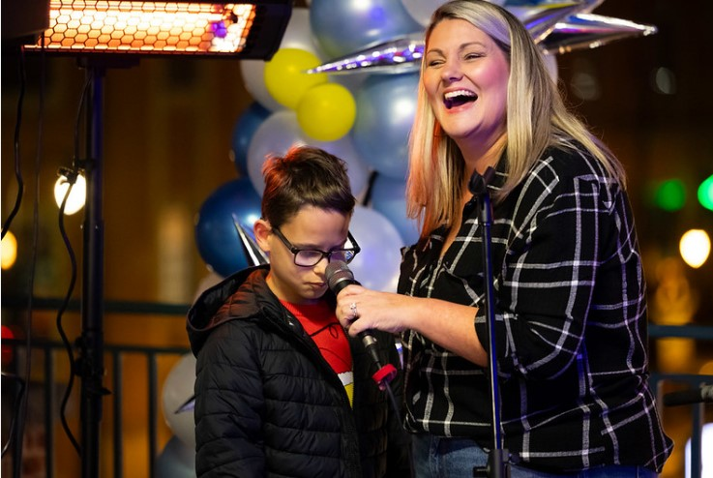
How does fundraising make a difference?
Jessica and Ford share how Ronald McDonald House helped their family at the 2025 Lights of Love Celebration.
Funds raised through Lights of Love are used to provide lodging, meals, transportation to the hospital, activities for patients, siblings, and caregivers, and other support while navigating childhood illness. Last year alone, we provided 28,964 overnight stays for families and helped them save $5.4 million. Most importantly, we helped keep them close to their children when they were needed most!
Is there a fundraising minimum?
There is no minimum (or maximum!) Every participant is encouraged to make a difference by asking friends and family for donations and by making a personal donation. All participants who raise $100 or more are considered Beacons of Hope and will receive a t-shirt at the event. Shirts cannot be mailed to those who were unable to attend the celebration. Illuminators who raise $1,000+ will receive special access to our VIP Party and will receive additional gifts.
How are donations made?
Donations may be made through secure gifts to your personal fundraising page with a credit card, PayPal, or bank transfer. Supporters will receive an emailed tax receipt.
Can my child fundraise?
Yes! If your child would like to raise funds but doesn't have an email address, we can set the giving page up for you. For more information, email Alyson@RMHCTriangle.org Children are some of our most powerful fundraisers and we love when children help other children.
I'm new to fundraising, where should I start?
Through your registration process, you will be given a customizable fundraising page. We encourage you to add a picture and tell your "why." Our team is here to help, just email Love@RMHCTriangle.org.
How do I fundraise on Facebook?
When you connect your giving page to a Facebook Fundraiser, your friends can donate with just one click! Be sure to check out our online fundraising tools.
If I set up a team, what kind of support will we receive?
Our team is ready to help every step of the way. We can even help inspire your team at a kickoff event at your location. Email questions to Love@RMHCTriangle.org.

