Frequently Asked Questions
CELEBRATION EVENT DETAILS
Is there a registration fee?
There is no fee to participate in the Lights of Love Celebration event on December 6. Instead, participants are encouraged to fundraise with our easy-to-use tools (customizable giving page that can be shared via text or social media) and make a personal donation to support our mission. Click here to register your attendance.
Celebration event activities
Our closing celebration at American Tobacco Campus on Sunday, December 6, from 3 – 7 pm, offers activities for families and kids of all ages. Features include:
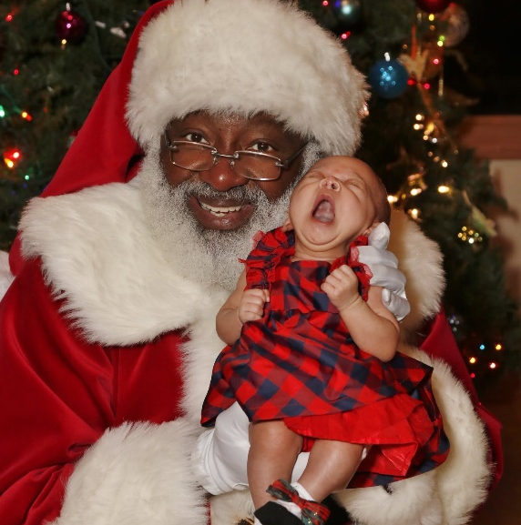
- Kids’ Spark Zone
- Live Entertainment
- Luminary Decorating Station
- Shine Photo Booth
- Therapy Dog Station
- Family Reunion for current & former Ronald McDonald House guests
- VIP Sponsor Party at Bay 7
- Visits with Santa
- And much more!

Parking
We recommend you park in the South or North parking decks on the American Tobacco Campus. The South Deck is ADA-accessible to the event. The North Deck gives better access to the VIP Party for sponsors and top fundraisers. (Note: There are two DPAC shows on Dec 6, so there will be extra demand for parking.)
American Tobacco South Deck (ADA accessible)
653 Jackie Robinson Drive
Durham, NC 27701

American Tobacco North Deck (Recommended for easy VIP Party access)
305 West Pettigrew Street
Durham, NC 27701
Is there food at Lights of Love?
Food will be available for purchase. Check back after November 15 to see a list of our participating food vendors.
What happens if it rains?
The Lights of Love Celebration event is on, rain or shine. If this changes, we will text all registered attendees.
Are there ADA accommodations?
American Tobacco Campus (ATC) in Durham is ADA compliant and wheelchair accessible. The American Tobacco South Deck features dedicated ADA-compliant spaces and elevator access, providing easy access to the event.
Can I attend if my child is in treatment or immunocompromised?
The Lights of Love celebration is mostly outdoors, however we recommend that all patients check with their healthcare provider before attending this event. We urge all attendees to respect those taking precautions such as masking or social distancing.
Can I drop off wish list items at the event?
We'll have two locations where you can conveniently drop off wish list items at the event.
For more information about holiday wish list needs, visit: Holiday Wish List.
Questions? Email Love@RMHCTriangle.org

